Pre-Battle Summary
- Determine Scenario: Choose from the Scenarios or decide randomly, or use Attack Ratings and the winner decides.
- Decide Attacker and Defender: Agree or decide randomly. If Attack Ratings were used to decide the Scenario, the player who chose the scenario is the Attacker.
- Choose Forces: Select a fleet from your Fleet List.
- Set up Celestial Phenomena: Determine battlezone from the Scenario and randomly generate phenomena.
- Generate Leadership: Roll on the leadership table appropriate for your fleet. (skip this step in Campaign play)
- Deploy Fleets: Instructions outlined in scenario.
- Determine First Turn: Instructions outlined in scenario.
- Begin fighting!

Raids (1-3) |  |  | Battles (4-6)
D6 Roll | Scenario |  | D6 Roll | Scenario
1 | Cruiser Clash |  | 1 | Exterminatus!
2 | The Bait |  | 2 | Surprise Attack
3 | The Raiders |  | 3 | Planetary Assault
4 | Blockade Run |  | 4 | Escalating Engagement
5-6 | Convoy |  | 5-6 | Fleet Engagement

Scenarios

Scenario One: Cruiser Clash
Forces
Each fleet consists of 1-4 cruisers (each side has the same number).

Battlezone
Do not place Celestial Phenomena

Setup
One player rolls a D6: On a 1-3 they deploy in FLEET A, on a 4+ they deploy in FLEET B
Next, each player rolls a D6. The lowest must place one cruiser, then players alternate deploying cruisers until all are deployed, facing the opposite table edge.
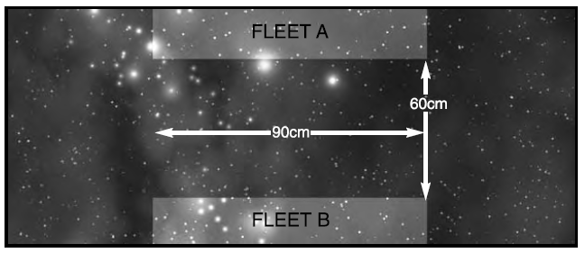

First Turn
Both players roll a D6, highest chooses to go first or second.

Game Length
8 turns or until one fleet is destroyed.

Victory Conditions
Normal Victory Points are not used. Players score one victory point for each point of damage they inflicted, one for each enemy ship crippled, and three for each enemy ship destroyed. The player who scores the most victory points is the winner.

Options
Advanced players may remove the points and size restriction on the fleets, place celestial phenomena, set up using the rules for Fleet Engagement, or use regular Victory Points.

Scenario Two: The Bait
Forces
Pursuing Forces: Up to 500pts
Pursued Forces: One ship (the Pursued Ship) up to 250pts, and additional ships up to 500pts

Battlezone
Roll a D6: 1-3 is Outer Reaches, 4+ is Deep Space.

Setup
The Pursued Ship is placed in the center of the board, facing a short table edge. Pursuers are deployed more than 60cm behind it. Reinforcements for the Pursued come in from the opposite side.
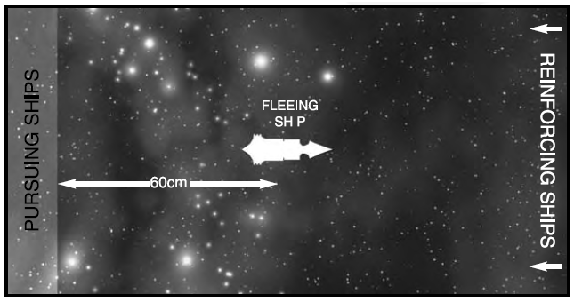

First Turn
The Pursued Ship takes the first turn.

Special Rules
Reinforcements for the Pursued Ship may come on during the first turn from the short board edge marked Reinforcing Ships. On any turn after that they may come in from a long table edge. Subtract 1 from the current turn, and multiply it by 30. Ships must be within this many centimeters from the Reinforcing Ships edge when entering from a long table edge.

Game Length
The game lasts until one fleet disengages or is destroyed.

Victory Conditions
Standard Victory Points.
Scenario Three: The Raiders
Forces
Agree on a points total. The defender may spend this, while the attacker may spend half as much.

Battlezone
Any.

Setup
The defender deploys their whole fleet within the area shown. All ships must face the same table edge. Each defending ship or squadron must be at least 20cm apart. The attacker moves their fleet on from any table edge on the first turn.
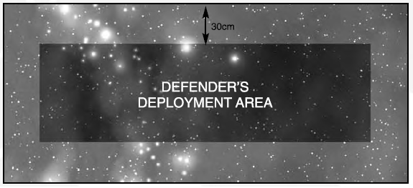

First Turn
The attacker takes the first turn and moves on from any table edge they choose.

Special Rules
For the first D6 turns, all defending ships suffer -1Ld due to the surprise.

Game Length
The game lasts 8 turns or until one fleet disengages or is destroyed.

Victory Conditions
Standard Victory Points.

Scenario Four: Surprise Attack
Forces
Both fleets pick the same size fleet. In addition, the defender gets D6x10 points to spend on planetary defences for every 500 points or part thereof in the defending fleet.

Battlezone
Primary or Inner Biosphere. Set up a planet in the middle of the table. If the game is 500pts or less, it is small, 501-1500pts medium, and more than 1500 large. Setup moons and rings as normal.

Setup
The defender may choose D3 ships/squadrons to be on full alert. These ships may be set up anywhere on the table at least 30cm from an edge. All other ships/squadrons are on standby, and must be placed to have one ship within 15cm of the planet’s edge, abeam to its surface. The attacker moves on from a table edge they choose.
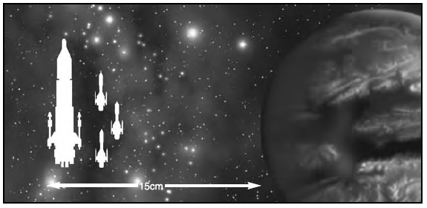

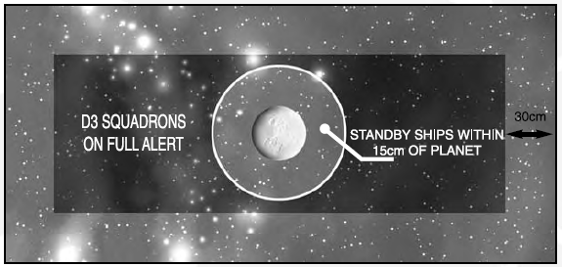

First Turn
The attacker takes the first turn and moves on from any table edge they choose.

Special Rules
See movement rules for ships on standby. Ships may leave standby by passing a leadership test. Note that this is not a command check and so if failed you may still make other tests. Ships may not go on special orders on the turn they leave standby.

Game Length
The game lasts until one fleet disengages or is destroyed.

Victory Conditions
Standard Victory Points.

Scenario Five: Blockade Run
Forces
Agree on a points total. The defender (blockader) may spend this, while the attacker (blockade runner) may spend half as much.

Battlezone
Outer Reaches or Deep Space.

Setup
Divide the table into three parts lengthwise as shown below. First, blockading ships/squadrons set up 60cm from the attacker’s table edge in a third of the table denoted by a D6 roll, see diagram. Blockading ships may face any direction. Then, attackers set up within 15cm of the attacker’s edge.
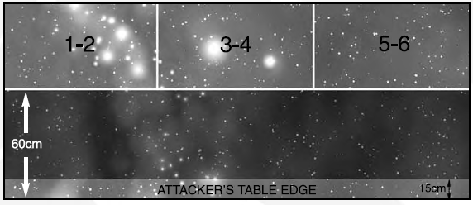
First Turn
Both players roll a D6. Highest may choose to go first or second.

Game Length
6 turns

Victory Conditions
Standard Victory Points. In addition, the attacker receives 100% of the points value of their ships that move off the defender’s table edge, or 25% if the ship is crippled.

Scenario Six: Convoy
Forces
The convoy must include at least two transports. For every two transports, the defender may spend 100pts. Transports are squadroned with a maximum of one squadron per pair of transports. The attacker gains D3 rolls on the table below, plus one for every pair of transports. Escort squadrons and ships are chosen from the attacker’s fleet list.
D6 Roll | Result
1 | One Deadfall Torpedo or Attack Craft Cluster
2 | Two Deadfall Torpedo or Attack Craft Clusters
3 | Three Deadfall Torpedo or Attack Craft Clusters
4 | A squadron of escorts worth up to 100pts
5 | A squadron of escorts worth up to 150pts
6 | One capital ship worth up to 200pts

Battlezone
Any. Setup terrain as normal.

Setup
The attacker sets up a contact marker for each result they rolled on the above chart. Markers must be placed 30cm apart and 30cm away from table edges. If contact markers cannot fit, place contact markers on top of ones already placed. The defender then rolls a D6 to randomly determine which short table edge their fleet enters from. The convoy may not enter within 45cm of any long table edge.
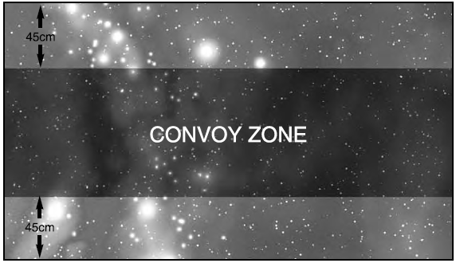

First Turn
The convoy has the first turn, and moves on from the indicated short board edge. Any ships which do not enter on the first turn must enter on the second or be lost in the warp.

Special Rules
When a convoy vessel moves within 30cm of a contact marker, reveal the marker when the convoy vessel has finished moving. Once the convoy player’s movement is finished, replace revealed markers with activated forces. The attacking player may voluntarily activate one counter at the beginning of their turn, unless any convoy ship is on special orders in which case they may activate two.
- Deadfall Torpedoes: Replace marker with Torpedo wave strength D6+2, oriented any way you wish. Torpedoes move 30cm.
- Attack Craft: Replace marker with D3+1 fighters, bombers, or assault boats in any mix, in any number of waves.
- Escort Squadron: Place one Escort in the squadron where the contact marker was, and then place the rest of the squadron in formation with this ship. No ship may be closer to the enemy than the first ship. They may face any direction, but all must face the same direction.
- Capital Ship: Replace the marker with a Capital Ship facing any direction.

Game Length
The game lasts until all transports leave the board or are destroyed.

Victory Conditions
Convoy transports which leave the board via the opposite short board edge count as having exited.
Transports Exiting | Result
Zero | Attacker Win
One | Attacker Marginal Win
Two | Defender Marginal Win
Three or more | Defender Win

Scenario Seven: Planetary Assault
Forces
Both fleets are of equal points. The defender gets D6x10pts to spend on defences for every 500pts or part thereof in the fleet. The attacker gets two transports for every 500pts or part thereof in the fleet.

Battlezone
Primary or inner biosphere. Place a planet no more than 150cm from a short board edge. Roll a D6: 1=small, 2-5=medium, 6=large. Place moons, rings, etc. Determine sunward edge and set up other celestial phenomena as normal.

Setup
The defender chooses whether each ship/squadron is on standby or patrol. Ships on standby are placed within the gravity well of the planet. For other ships/squadrons, roll a D6 for each. 1-3: attacker sets them up, 4-6: defender does. Ships must be placed more than 30cm away from any table edge, though the owning player decides facing. The attacker then sets up their fleet within 15cm of the short edge opposite the planet, as shown below. In addition, you must set up a separate low orbit table.
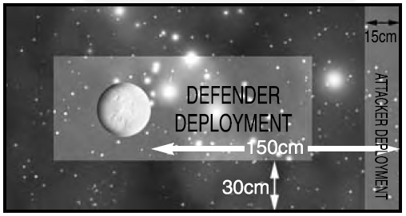

First Turn
Both players roll a D6, highest chooses to go first or second.
Special Rules
Attacking ships earn Assault Points for moving to within 30cm of the planetary edge of the low orbit table. For each turn within 30cm of the planetary edge, capital ships earn 1 assault point and transports earn 2. Ships only earn assault points if they do nothing else that turn.

Game Length
The game lasts until all one fleet is destroyed or disengages, or the attacker scores 10 or more assault points. NOTE: if the defender has no defences, they can disengage for an automatic win! Players must agree not to do this, or give the defender one free ground based defence to prevent such an event.

Victory Conditions
Add up the assault points earned by the attacker +1 for every 500 victory points earned by the attacker, and -1 for every 500 victory points earned by the defender. Consult the table below.
Assault Points | Result
0-1 | Defender Win
2-5 | Defender Marginal Win
6-9 | Attacker Marginal Win
10+ | Attacker Win

Scenario Eight: Escalating Engagement
Forces
Both fleets split into 5 divisions. Each player take 5 contact markers and assigns part of their fleet to each marker, note which ships go with each marker. There are no restrictions to how many ships/squadrons can be with each marker as long as each marker has at least one.

Battlezone
Any. Setup terrain as normal.

Setup
Each chooses one of their markers at random to deploy. Roll to see who places their marker first. Markers may not be placed with 30cm of a table edge or 60cm of an enemy marker. Once markers are placed, deploy that division within 10cm of the marker.
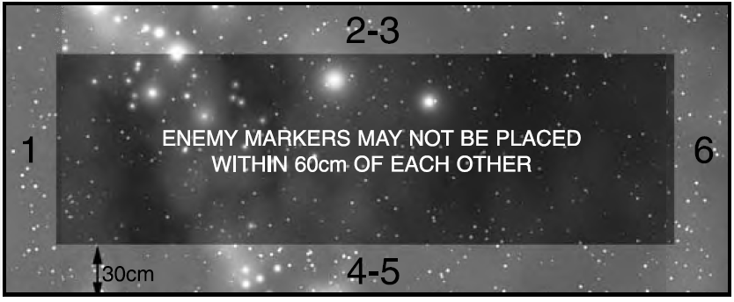

First Turn
Both players roll a D6, highest chooses to go first or second.

Special Rules
In the End Phase of each player’s turn, they randomly choose another of their contact markers to deploy. Randomly choose the table edge per the diagram above. The marker may not be placed within 60cm of an enemy, and if a friendly ship is within 30cm of that table edge, the marker must be deployed within 30cm of a friendly ship. At the beginning of a player’s turn, they may try to bring in divisions from markers already on the board. Roll a D6 for each contact marker and compare it to the score needed based on the speed of the slowest ship in the division.
Speed of slowest ship in division | Up to 20cm | 25cm | 30cm or more
Score needed to arrive* | 5+ | 4+ | 3+
*If friendly ships are within 30cm of the marker, add 2 to this roll.
If a roll is successful, the division may enter from anywhere on the table edge 10cm from the marker. If unsuccessful, the marker may move along the edge at the speed of the slowest ship.

Game Length
The game lasts until one fleet disengages or is destroyed.

Victory Conditions
Standard Victory Points.

Scenario Nine: Exterminatus!
Forces
Both fleets are of equal points. For every 1000pts or part thereof, the attacker must nominate a capital ship as an Exterminator. Exterminators lose their prow weapons to gain exterminator weapons, which cannot be fired normally. Blackstone Fortresses are exempt from this. The defender receives D6x10 points to spend on defences for every 500pts or part thereof in the fleet. In addition, the defender may spend up to 25% of their normal fleet points on defences.

Battlezone
Primary or Inner Biosphere. Place a planet no more than 150cm from a short board edge. Roll a D6: 1=small, 2-5=medium, 6=large. Place moons, rings, etc. Determine sunward edge and set up other celestial phenomena as normal.

Setup
The defender chooses one ship or escort squadron for every 500pts or part thereof in their fleet. These are not deployed; deploy all other ships at least 30cm away from the board edge. The attacker sets up their entire fleet within 15cm of the short board edge furthest from the planet. You will also need a separate low orbit table.
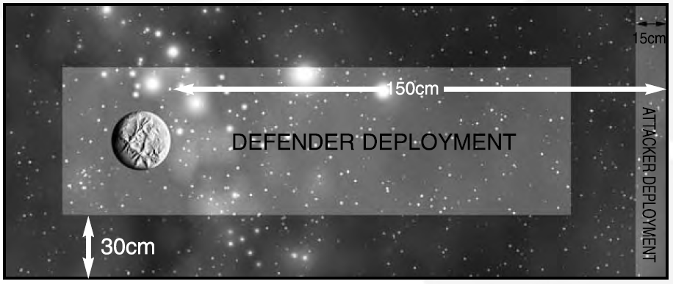

First Turn
Both players roll a D6, highest chooses to go first or second.

Special Rules
A ship with Exterminator weapons must come within 45cm of the low orbit planetary edge. At the start of each turn when it is within 45cm, roll a D6. On a 4+ the planet is exterminated. Defending ships do NOT need a leadership test to target an exterminator.
At the start of each defending player’s turn, roll a D6 for each ship not deployed. Compare it to the chart below based on the speed of the ship/squadron.
Ship’s speed | Up to 20cm | 25cm | 30cm or more
Score needed to arrive | 5+ | 4+ | 3+
If successful, the ship arrives on a random board edge.
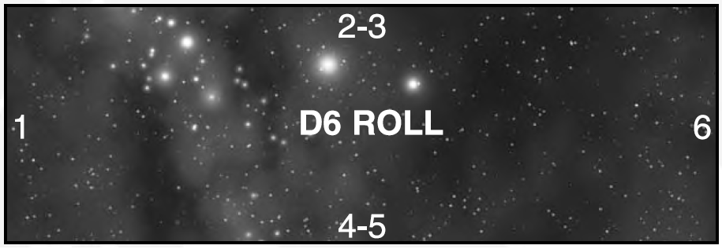

Game Length
The game ends when one fleet disengages, all the attacker’s Exterminators are destroyed, or an Exterminator destroys the planet.

Victory Conditions
If a fleet disengages, it loses. If all attacking Exterminators are destroyed, the defender wins. If the planet is exterminated, the attackers win.

Exterminatus! Missions in Campaigns
If playing in a campaign and the attacker exterminates the planet, roll a D6. On a 1-3, the system becomes uninhabited. On a 4+, roll again. On a 1-3 the system is changed to an Agri-world. On a 4+, it is changed to a Mining Planet.

Scenario Ten: Fleet Engagement
Forces
Both fleets are picked to an equal points value.

Battlezone
Any. Setup terrain as normal.

Setup
Each player chooses one of the three types of formations: Sphere, Wedge, or Cross. Consult the table below, and then setup according to the deployment zone indicated. If two setups are indicated, each player rolls a D6. +1 for having the ship with the highest speed in either list in your fleet, +1for the Admiral with the highest Leadership, +1 for the most Escort class ships in your fleet. Winner may decide which of the two to use. After setup is determined, each player rolls a D6; loser must deploy one ship/squadron. Alternate until all ships/squadrons are deployed.
-Divisions
Some of the deployment zones in the below maps are divided into multiple divisions. Players must have at least one ship/squadron in each division.
-Approach Angle
Ships must be deployed facing the angle of the arrows shown in the zone in which they deploy.

Your  Choice | Opponent’s Choice
Your  Choice | Sphere | Wedge | Cross
Sphere | B | A(d. grey)/ C(d. grey) | A(d. grey)/ D(d. grey)
Wedge | A(white)/ C(white) | D(d. grey)/ D(white) | B
Cross | A(white)/ D(white) | B | B
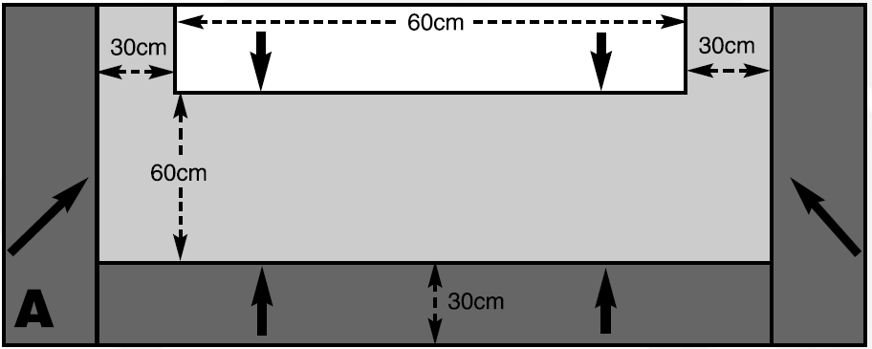

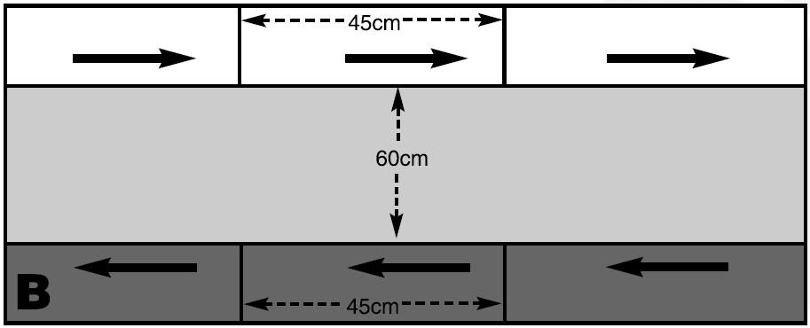

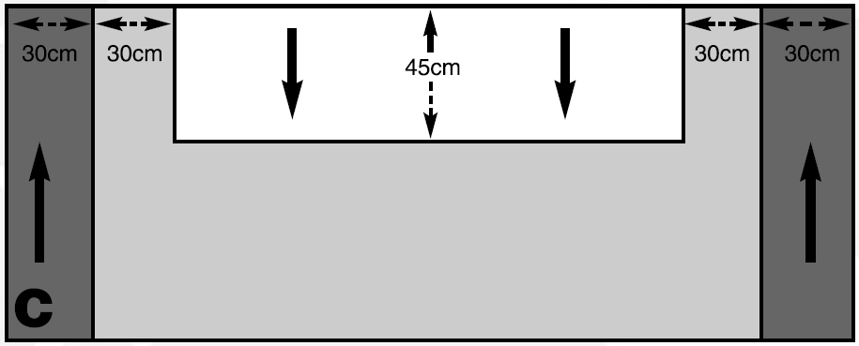

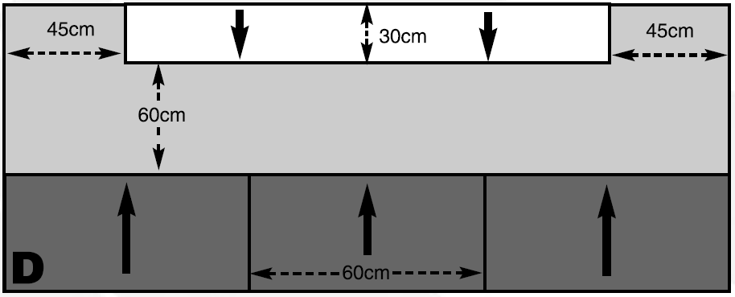

First Turn
Both players roll a D6, highest chooses to go first or second.

Game Length
The game lasts until one fleet disengages or is destroyed.

Victory Conditions
Standard Victory Points.

